St. Joseph's College of Engineering and Technology, Palai (Autonomous)
Department of Computer Science and Engineering | 24SJPCCST503 – Machine Learning | Course Project: Investigation Challenge | AY 2026–2027
When Should a Simpler Model Be Preferred Over a Complex One?
An investigation of accuracy, complexity, interpretability and computational cost in vehicle fuel-efficiency prediction (Team 15 – Model Complexity)
1. Team Members
GANGA V | JUDIT JEBY | SAVIO BIJO THOMAS | KENAZ MATHUKUTTY
2. Research Question
Assigned question: When should a simpler machine-learning model be preferred over a more complex one?
Operational question: For predicting vehicle fuel efficiency (MPG), is the improvement in predictive performance obtained by moving from Linear Regression to Decision Tree Regression and Random Forest Regression large enough to justify the additional model complexity, computational cost and loss of interpretability – and how well does each model generalize to unseen data?
Problem statement. Machine learning offers models of very different complexity for the same prediction problem. A more complex model may achieve better predictive performance by learning complicated patterns, but it can also require more computational resources and be harder to interpret. The most accurate model is therefore not always the most suitable one. This project investigates when a simpler model should be preferred by comparing three regression models on the same task and under identical experimental conditions.
Abstract. Three regression models of increasing complexity – Linear Regression, Decision Tree Regression and Random Forest Regression – are compared on the Auto MPG dataset. They are evaluated with Mean Absolute Error (MAE), Root Mean Squared Error (RMSE) and R², together with model complexity, interpretability, computational requirements and generalization to unseen data. The results are analysed to determine whether the extra predictive performance of a more complex model justifies its additional cost, and to identify the situations in which a simpler model is sufficient and should be preferred, as well as those in which a more complex model is justified.
3. Hypotheses
- H1: Decision Tree and Random Forest achieve lower test error than Linear Regression, because fuel efficiency has nonlinear relationships with features such as weight, displacement and horsepower that a linear model cannot represent.
- H2: A single, unpruned Decision Tree generalizes worse than Random Forest (larger train–test gap), because one deep tree fits noise while averaging many trees reduces variance.
- H3: The gain of the best complex model over Linear Regression is modest relative to its added cost, so that Linear Regression is “good enough” and preferable when interpretability and speed matter.
- H4: Computational cost and loss of interpretability increase monotonically with complexity (Linear Regression < Decision Tree < Random Forest).
4. Theoretical Background
Bias–variance trade-off. Expected test error decomposes into bias², variance and irreducible noise. Simple models have high bias but low variance; flexible models reduce bias but are more sensitive to the particular training sample and can overfit (Hastie et al., 2009). Greater complexity therefore helps only if the bias reduction outweighs the added variance – which depends on how nonlinear the true relationship is and how much data is available.
Linear Regression fits a weighted sum of the features by minimizing squared error. Each coefficient has a direct meaning (change in MPG per unit of a feature, other features held fixed), it trains in closed form and predicts almost instantly. It cannot capture nonlinear effects or interactions unless they are engineered, and correlated inputs (cylinders, displacement, horsepower and weight are strongly related in vehicles) inflate the variance of individual coefficients even when predictions remain stable.
Decision Tree Regression (CART; Breiman et al., 1984) recursively partitions the feature space and predicts the mean target of each region. It captures nonlinearities and interactions without scaling and, when shallow, can be read as a set of rules. A fully grown tree, however, memorizes the training data (near-zero training error), is unstable to small changes in the data and has many leaves that are difficult to interpret.
Random Forest Regression averages many deep trees, each grown on a bootstrap sample with randomized split candidates (Breiman, 2001). Averaging strongly reduces variance, usually giving better accuracy and stability than a single tree, but the model consists of hundreds of trees. It is a “black box” in practice – only aggregate summaries such as feature importances are readable – and needs more time and memory to train and predict.
Interpretability and cost. Rudin (2019) argues that where an interpretable model performs almost as well as a black box, the interpretable model should be preferred. This motivates treating accuracy, interpretability and computational cost as joint criteria rather than optimizing error alone. Metrics: MAE is the mean absolute error in MPG; RMSE is the square root of mean squared error and penalizes large errors more; R² is the proportion of target variance explained.
5. Dataset
Dataset. The Auto MPG dataset (Quinlan, 1993; UCI Machine Learning Repository): 392 cars from model years 1970–1982 (the copy used contains complete records only; the original file has 398 rows, six of which lack horsepower). Type: regression. Target: MPG (miles per gallon). Purpose: predict the fuel efficiency of a vehicle from its characteristics. Features: Cylinders, Displacement, Horsepower, Weight, Acceleration, Model Year and Origin (1 = USA, 2 = Europe, 3 = Japan). The car-name column is an identifier and is not used as a feature.
Why it suits this investigation. The vehicle characteristics have both simple and nonlinear relationships with fuel efficiency (for example, MPG falls steeply and then flattens as weight and displacement increase). This allows a simple linear model to be compared fairly with more flexible tree-based models. The dataset is small and clean enough for all three models to be trained under identical conditions and for computational cost to be measured directly.
Limitations and biases. The cars are from 1970–1982 and may not represent modern vehicles. The copy of the data used has no missing values (the code converts horsepower to numeric and drops any incomplete rows), so no imputation was needed. With only 79 test rows, test metrics are noisy, so cross-validation is reported alongside the single split. Because the data are small, absolute training times are tiny for every model; the cost comparison is therefore about relative growth, not real-world burden.
6. Experimental Design
Changed: only the learning algorithm (three models, Table 1). Measured: Test MAE, Test RMSE (primary metric), Test R², Train R², the generalization gap (Train R² − Test R²), 5-fold cross-validated R² (mean ± SD, computed on the training set), training time and model size (coefficients, tree nodes, number of trees). Controlled: one fixed 80/20 split (random_state = 42; 313 training and 79 test cars) reused by every model; the same features; one-hot encoding of Origin (drop-first, giving origin_2 and origin_3), applied to the whole dataset before splitting (a deterministic transform that leaks no target information); and standardization for Linear Regression only (trees are scale-invariant), done inside a scikit-learn Pipeline so the scaler is fitted on training data only. No imputation was needed. Hyperparameters are fixed and untuned so that differences reflect model class, not tuning effort: Decision Tree with max_depth = 5 and Random Forest with 100 trees and max_depth = 10 (random_state = 42 for both). Sensitivity runs additionally varied tree depth (3, 5, 10) and forest size (10, 50, 100 trees). Compared: LR → DT and LR → RF measure the value of added complexity; DT → RF measures the value of ensembling.
Decision rule (set before running). A more complex model is regarded as justified over a simpler one only if it lowers Test RMSE by more than 5% and its 5-fold cross-validated R² exceeds that of the simpler model by more than the fold-to-fold standard deviation; otherwise the simpler model is preferred. Training time is a single measurement of model.fit() on the same machine.
Table 1. Models compared
ID | Model | Complexity | Key settings and preprocessing
A | Linear Regression | Low | Ordinary least squares; standardization (in a Pipeline), one-hot Origin
B | Decision Tree Regressor | Medium | max_depth = 5, random_state = 42; one-hot Origin, no scaling
C | Random Forest Regressor | High | 100 trees, max_depth = 10, random_state = 42; one-hot Origin, no scaling

7. Results
Results come from a single run of the team notebook (random_state = 42; 313 training and 79 test cars). Cross-validation is 5-fold on the training set and is scored with R².
Table 2. Predictive performance of the three models (single split; MAE and RMSE in MPG, R² unitless)
Model | Train R² | Test MAE | Test RMSE | Test R² | CV R² (mean ± SD) | Gap (Train − Test R²)
Linear Regression | 0.829 | 2.462 | 3.256 | 0.792 | 0.810 ± 0.023 | 0.036
Decision Tree | 0.931 | 2.303 | 3.307 | 0.786 | 0.799 ± 0.032 | 0.145
Random Forest | 0.980 | 1.733 | 2.429 | 0.884 | 0.854 ± 0.028 | 0.096

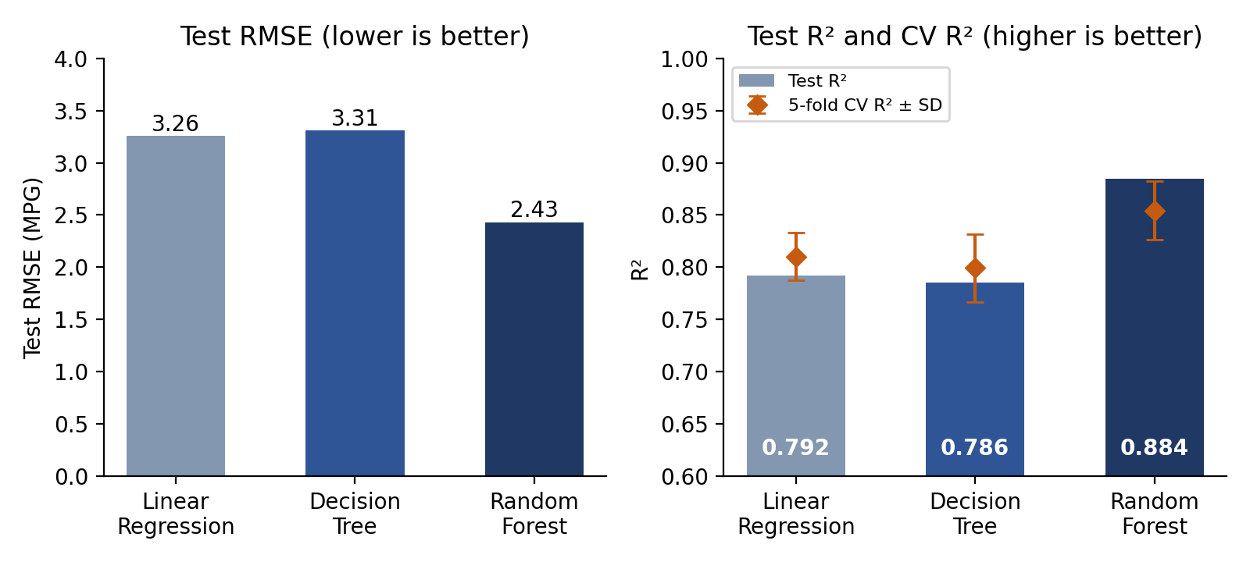
Figure 1. Test RMSE (left) and Test R² with 5-fold cross-validated R² ± SD (right) for each model.
Table 3. Complexity, interpretability and computational cost
Model | Model size | Interpretability | Training time (s)
Linear Regression | 8 coefficients + intercept | High – each coefficient readable | 0.0045
Decision Tree | 57 nodes (29 leaves), depth 5 | Medium – rules readable but many and unstable | 0.0020
Random Forest | 100 trees, 29,080 nodes (max depth 10) | Low – only aggregate feature importances | 0.1414

Table 4. Change in performance and cost when moving to a more complex model
Comparison | Δ Test RMSE (MPG, %) | Δ Test R² | Training-time factor | Verdict (decision rule)
LR → Decision Tree | +0.051 (+1.6%) | −0.007 | 0.44× | Not justified – slightly worse than LR, no gain for the added complexity
LR → Random Forest | −0.827 (−25.4%) | +0.092 | 31.4× | Justified – RMSE gain well above 5% and CV R² gain (+0.044) exceeds the fold SD
Decision Tree → RF | −0.878 (−26.6%) | +0.099 | 70.7× | Justified – RMSE gain well above 5% and CV R² gain (+0.055) exceeds the fold SD

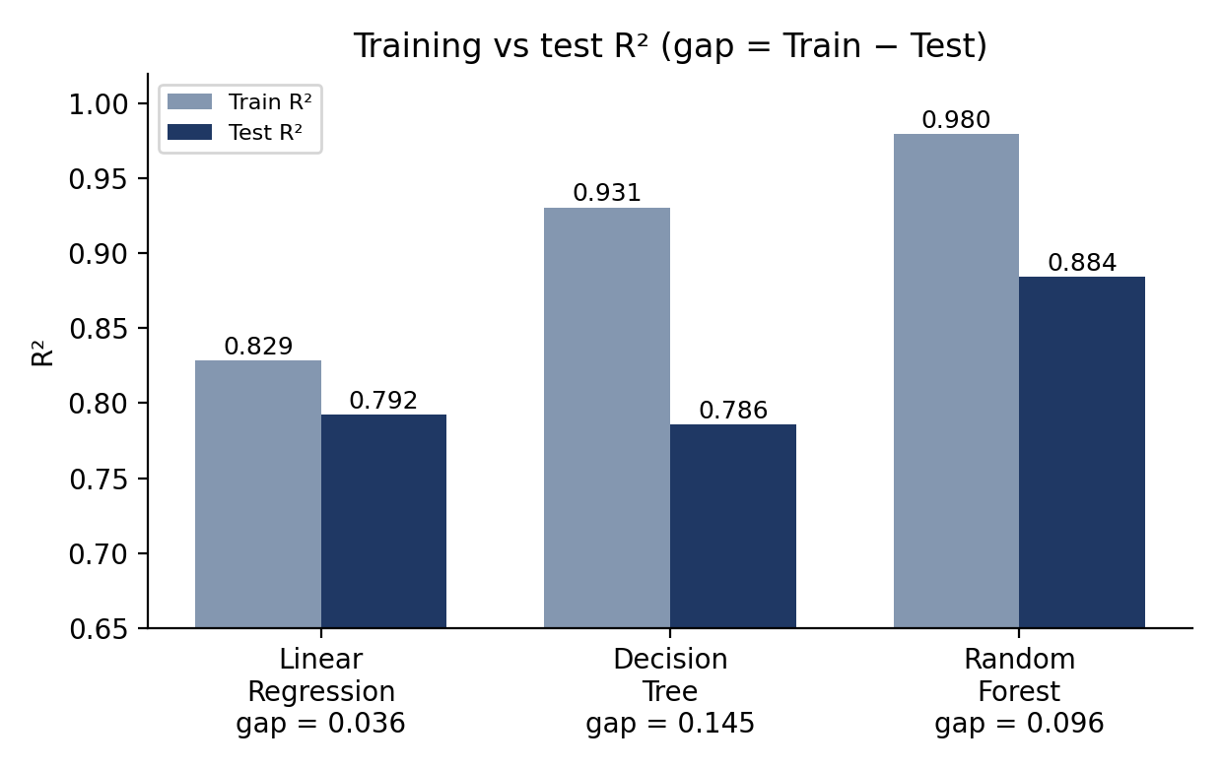
Figure 2. Training versus test R² (the gap is the visible overfitting signal).
8. Analysis and Interpretation
H1 – complex models beat Linear Regression (partly supported). Random Forest clearly beats Linear Regression: Test RMSE falls from 3.26 to 2.43 MPG (−25.4%) and Test R² rises from 0.792 to 0.884; its cross-validated R² is also higher (0.854 versus 0.810, a gain of 0.044 that is about twice the fold-to-fold SD of Linear Regression, 0.023). The Decision Tree (depth 5) does not: its Test RMSE is slightly higher than that of Linear Regression (3.31 versus 3.26 MPG, +1.6%) and its Test R² and CV R² are slightly lower, although its Test MAE is lower (2.30 versus 2.46), so it is often closer but makes a few larger errors. The nonlinearity argument therefore holds for the ensemble but not for a single shallow tree. In the standardized Linear Regression, weight has by far the largest coefficient (−5.39), followed by model year (+2.89) and displacement (+1.99); the positive sign of displacement is counter-intuitive and reflects its strong correlation with weight, cylinders and horsepower, which makes individual coefficients unreliable. The Random Forest ranks displacement (0.42), horsepower (0.17), weight (0.14), cylinders (0.14) and model year (0.10) highest, sharing credit among correlated variables; the single tree puts 0.67 of its importance on displacement alone.
H2 – Decision Tree overfits more than Random Forest (supported). Even limited to depth 5, the Decision Tree fits its training data far better than unseen data: Train R² 0.931 versus Test R² 0.786, a gap of 0.145 (Table 2, Figure 2). The depth experiment shows the trend: from depth 3 to 5 to 10, Train R² rises 0.840 → 0.931 → 0.995 while Test R² only moves 0.733 → 0.786 → 0.798, so the depth-10 tree (gap 0.196) is close to memorizing the training set; its CV R² (0.781, SD 0.051) is lower and less stable than at depth 5 (0.799). Random Forest has a smaller gap (0.980 − 0.884 = 0.096) and the best test score. The relevant point is that a small training error is not evidence of a good model: the Random Forest’s training R² is very high too, and the gap must be read together with test error. Note that the notebook’s baseline tree is depth-limited rather than fully unpruned, so H2 was tested in a milder form than stated.
H3 – is the simpler model “good enough”? (no – Linear Regression is not sufficient if accuracy is the priority). Applying the pre-set decision rule: the gain of Random Forest over Linear Regression is 25.4% in Test RMSE, which is above the 5% threshold, and its CV R² advantage (0.044) is larger than the CV standard deviation (0.023–0.028). Linear Regression misses by about 0.83 MPG more (RMSE) than Random Forest, so the gain is not modest and H3 is not supported for the forest. The Decision Tree, in contrast, gives no gain at all for its added complexity, so Linear Regression is preferable to it. Note that this judgement depends on the application: where a few tenths of an MPG matter, a gain of this size is worth its cost; where explaining the prediction matters, Linear Regression – still explaining about 79% of the variance with 8 readable coefficients – may be preferred.
H4 – cost and interpretability grow with complexity (partly supported). Table 3 shows training time rising by about 31× from Linear Regression (0.0045 s) to Random Forest (0.141 s), and the model size growing from 8 coefficients to 29,080 tree nodes (100 trees). Interpretability falls in the same order. The ordering is not strictly monotonic, however: the depth-5 Decision Tree trained faster (0.0020 s) than Linear Regression, whose pipeline includes standardization. Timings are single measurements and noisy – the same 100-tree forest took 0.14 s in the baseline run and 0.32 s in the tree-count experiment – so the factors are only indicative. Because the dataset has fewer than 400 rows, all absolute times are small; the practical burden would become important only for much larger data or frequent retraining.
Why the trade-off appears. Linear Regression sits at the high-bias, low-variance end and Decision Tree at the low-bias, high-variance end, while Random Forest reduces the variance of trees by averaging. Whether the extra flexibility pays off is therefore determined by how nonlinear the MPG relationships are relative to the small sample – the bias–variance trade-off seen in Figure 2.
9. Critical Evaluation and Limitations
- Single split and small test set. The single 80/20 split leaves only 79 test cars, so differences of a few percent may lie within noise. Cross-validation partly addresses this, but it was run on the 313 training cars only and scored with R² rather than RMSE; repeated splits and different seeds would quantify the noise further.
- Untuned models. Hyperparameters were fixed, with only a light sensitivity check (three tree depths, three forest sizes) and no systematic tuning. A better-tuned tree, a deeper or larger forest, or a regularized linear model could change the conclusions; the comparison shows near-default behaviour, not each model’s best possible performance.
- Timing measurement. Training times come from a single call to fit() per model, and prediction time was not measured. The same forest took 0.14 s in one run and 0.32 s in another, so the timings indicate orders of magnitude rather than exact values.
- Dataset scale and age. Only 392 cars from 1970–1982 are used. The computational-cost comparison is therefore small in absolute terms, and conclusions may not transfer to modern, larger vehicle datasets.
- Correlated features. Cylinders, displacement, horsepower and weight are strongly correlated. This affects the interpretation of individual linear coefficients and of tree-based importances, which may split credit between correlated variables.
- Limited scope. Three algorithms and one prediction task. Interpretability was judged qualitatively rather than measured with a formal metric, and other model families (regularized linear models, gradient boosting) were not compared.
10. Conclusion
What happened. Random Forest improved on Linear Regression enough to pass the decision rule: Test RMSE fell by 25.4% (3.26 → 2.43 MPG), Test R² rose from 0.792 to 0.884 and CV R² from 0.810 to 0.854 (a gain larger than the fold-to-fold SD), at the price of about 31× the training time and roughly 29,000 tree nodes instead of 8 coefficients. The single Decision Tree did not justify its complexity: it performed no better than Linear Regression (Test RMSE 3.31 versus 3.26 MPG). On this small dataset all computational costs are tiny (the forest trains in about 0.14 s), so the main price of the forest here is lost interpretability rather than computation.
Why. The gain comes from variance reduction, not simply from flexibility. A single depth-5 tree has lower bias than a straight line but higher variance (Train R² 0.931 versus Test R² 0.786, gap 0.145), which cancels its advantage; averaging 100 trees keeps the flexibility while reducing variance (gap 0.096, Test R² 0.884). Linear Regression has the smallest gap (0.036) but also the lowest fit, which is consistent with bias from the nonlinear relationships between MPG and features such as weight and displacement. In general, a simpler model should be preferred when its performance is within the pre-set tolerance of the best model, when interpretability or speed is required, or when data are limited; a more complex model is justified when it gives a clear, stable improvement that matters for the application.
Confidence. Moderate to high that the ranking of the models is real (Random Forest best; Linear Regression and Decision Tree roughly equal); low for small differences such as Linear Regression versus the Decision Tree (about 0.01 in R², well within the 0.02–0.03 fold-to-fold SD), since the evidence rests on one split of 79 test cars plus 5-fold cross-validation. Repeated cross-validation, tuning of each model, and additional datasets would raise confidence.
11. AI Usage Declaration
AI tool(s) used | Claude (Anthropic) for drafting this report.
Purpose of using AI | Code structure and explanation; documentation; drafting and formatting the report text.
Parts assisted by AI | AI was used to assist with experiment code, understanding model-comparison concepts, interpreting results, and drafting the report. The experimental execution, result verification, and final conclusions were reviewed by the team.
How output was verified | The notebook was executed by the team and the reported numerical results were cross-checked with the actual notebook outputs. The ML concepts and explanations were also reviewed against the course material and standard references.
One suggestion modified, rejected or corrected | AI-generated suggestions were reviewed rather than used directly. Where suggestions did not match the actual experimental results or project requirements, they were modified or rejected based on the team’s notebook outputs and the prescribed project guidelines.
12. References
Breiman, L. (2001). Random forests. Machine Learning, 45(1), 5–32.
Breiman, L., Friedman, J., Olshen, R., & Stone, C. (1984). Classification and Regression Trees. Wadsworth.
Dua, D., & Graff, C. (2019). UCI Machine Learning Repository: Auto MPG data set. University of California, Irvine.
Hastie, T., Tibshirani, R., & Friedman, J. (2009). The Elements of Statistical Learning (2nd ed.). Springer.
Pedregosa, F., et al. (2011). Scikit-learn: Machine learning in Python. Journal of Machine Learning Research, 12, 2825–2830.
Quinlan, J. R. (1993). Combining instance-based and model-based learning. Proceedings of the 10th International Conference on Machine Learning, 236–243.
Rudin, C. (2019). Stop explaining black box machine learning models for high stakes decisions and use interpretable models instead. Nature Machine Intelligence, 1, 206–215.

